**SQL Exercise 10**

1. Display the Supplier name and the Quantity sold.

select sname,qty from supplier join spj on supplier.sid=spj.sid group by supplier;

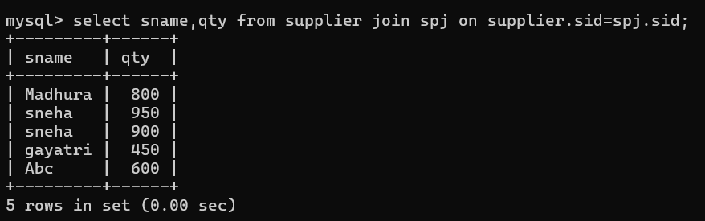

1. Display the Part name and Quantity sold.

select pname,qty from parts join spj on parts.pid=spj.pid;

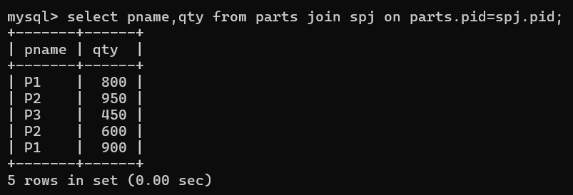

1. Display the Project name and Quantity sold.

select jname,qty from projects join spj on projects.jid=spj.jid;

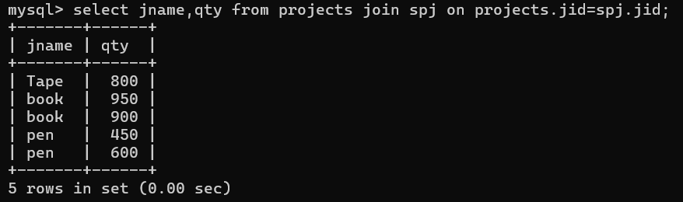

1. Display the Supplier name, Part name, Project name and Quantity sold.

select sname,pname,jname,qty from spj

join supplier on supplier.sid=spj.sid

join parts on parts.pid=spj.pid

join projects on projects.jid=spj.jid;

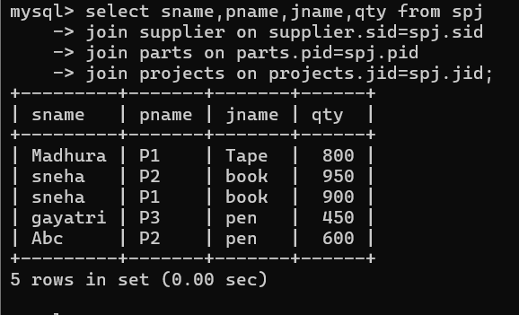

1. Display the Supplier name, Supplying Parts to a Project in the same City.

select sname,pname,jname,projects.city from spj

join projects on projects.jid=spj.jid

join supplier on spj.sid=supplier.sid

join parts on spj.pid=parts.pid

where supplier.city=projects.city;

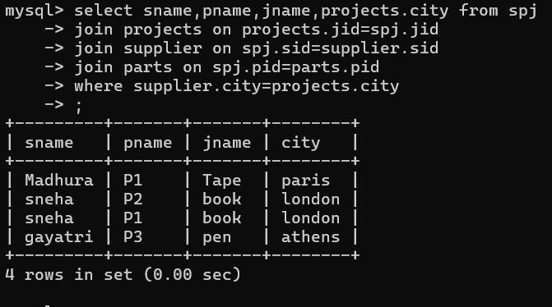

1. Display the Part name that is ‘Red’ is color, and the Quantity sold.

select pname,qty from spj join parts on parts.pid=spj.pid

where parts.color='red';

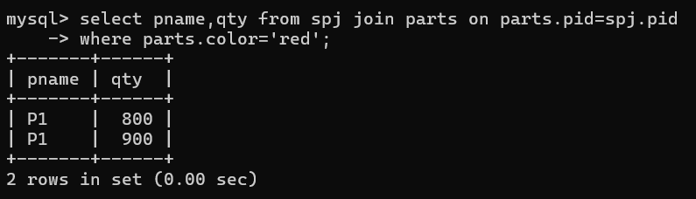

1. Display all the Quantity sold by Suppliers with the Status = 20.

select qty,sname from spj join supplier on supplier.sid=spj.sid

where supplier.status=20;

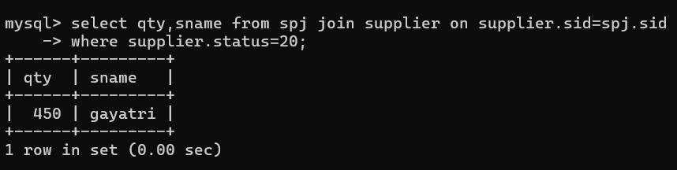

1. Display all the Parts and Quantity with a Weight > 14.

select qty,pname,weight from spj join parts on parts.pid=spj.pid

where parts.weight>14;

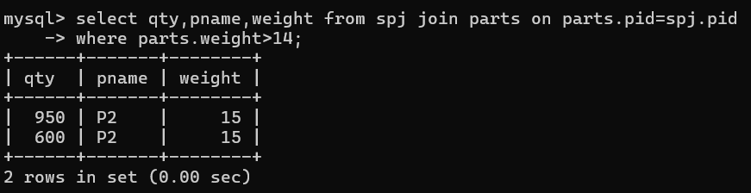

1. Display all the Project names and City, which has bought more than 500 Parts.

select jname,projects.city,qty from spj

join parts on parts.pid=spj.pid

join projects on projects.jid=spj.jid

where spj.qty>500;

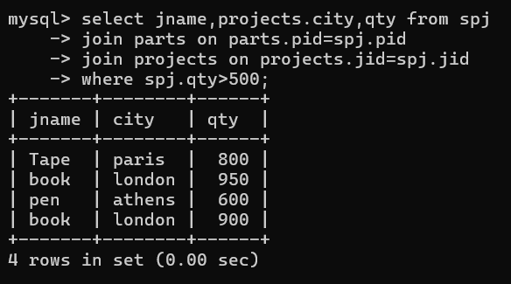

1. Display all the Part names and Quantity sold that have a Weight less than 15.

select pname,qty,parts.weight from spj

join parts on parts.pid=spj.pid

where parts.weight<15;

